- Write a Java program that prints "VALID" only if a number: - Done

is divisible by 3

NOT divisible by 5

lies between 50 and 200 (inclusive)
Otherwise print "INVALID"
➡️ Use only one if statement

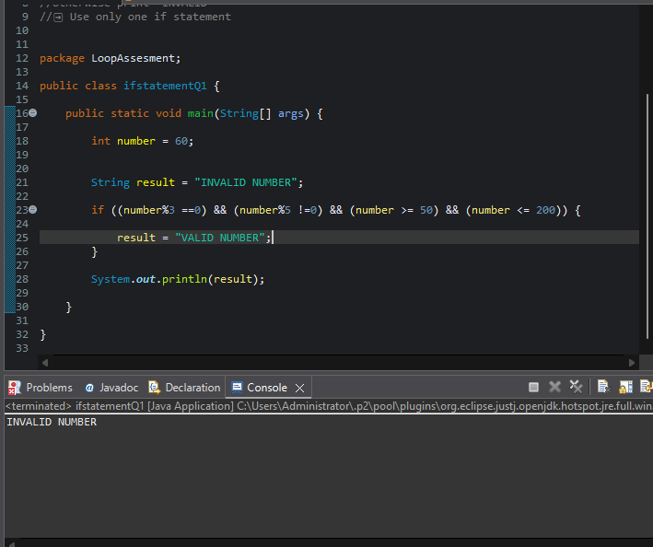
-----------------------------------------------------------------------
2.
- Done
Given three integers a, b, and c, print the second largest number using:

Only if–else
package LoopAssesment;

public class ifelseonlyQ2 {

public static void main(String[] args) {

int a = 120, b = 40, c=600;
int max;

if (a>b) {
if (a>c) {
max = a;
} else {
max = c;
}
} else {
if (b>c) {
max = b;
} else {
max = c;
}

}
if (max == a) {
if (b>c) {
System.out.println(" b is the second largest");
} else {
System.out.println("c is the second largest");
}
} else {
if (max == b) {
if (a>c) {
System.out.println("a is the second largest");
} else {
System.out.println("c is the second largest");
}
} else {
if (max == c && a>b) {
System.out.println("a is the second largest");
} else {
System.out.println("b is the second largest");
}
}

}

}

}

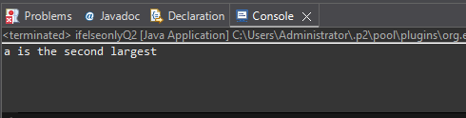
-----------------------------------------------------------------------
3.Write a program to check if a year is a leap year: - Done

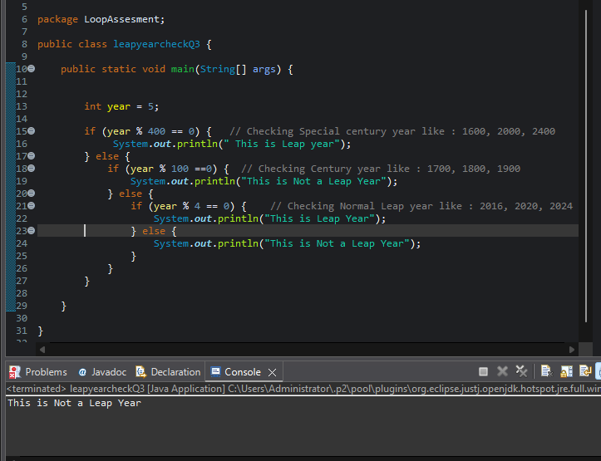
-----------------------------------------------------------------------
4.

Input an integer and determine whether: - Done

It is positive and divisible by 4

OR negative and divisible by 6

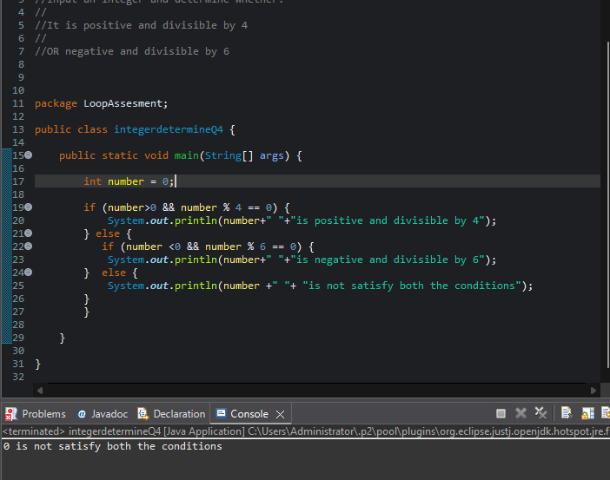
-----------------------------------------------------------------------
5.

Write a program that prints: - Done

"A" if number divisible by 2 and 3

"B" if divisible by 3 and not by 2

"C" if divisible by 2 and not by 3

"D" otherwise

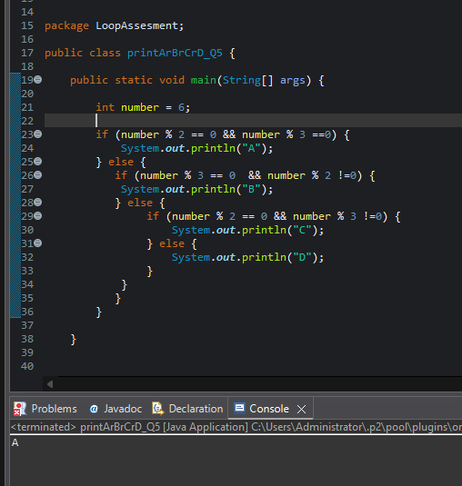
-----------------------------------------------------------------------
-----------------------------------------------------------------------

🔹 NESTED IF–ELSE (Complex Conditions)
6.

Given marks in Math, Physics, Chemistry, determine eligibility: - Done

Math ≥ 60

Physics ≥ 50

Chemistry ≥ 40
AND

Total ≥ 180 OR Math + Physics ≥ 120

Then print elligible for Physics hons
else
print not elligbile

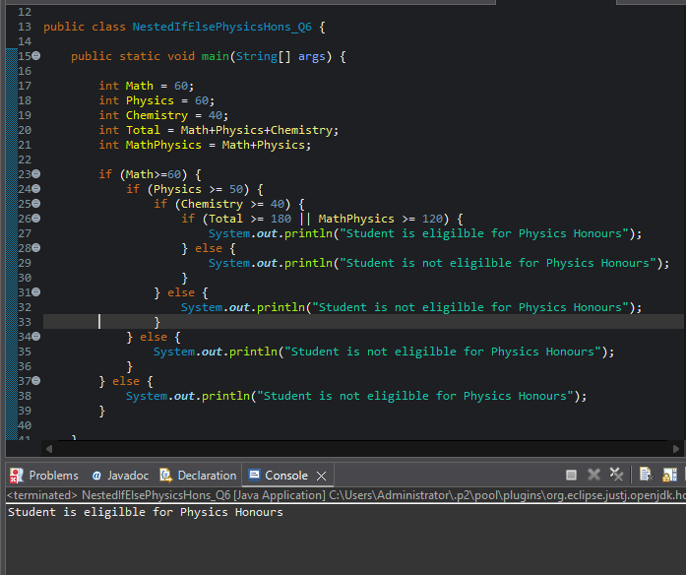
-----------------------------------------------------------------------
7.Write a program to find the largest of four numbers using: - Done

Nested if–else only

No loops

No arrays

package LoopAssesment;

public class NestedIfElseFindLargestNumber_Q7 {

public static void main(String[] args) {

int A = 10;
int B = 20;
int C = 15;
int D = 15;

if (A==B && B ==C && C==D) {
System.out.println("All the Numbers are equal");
} else {
if (A>=B) {
if (A>=C) {
if (A>=D) {
System.out.println("A is the Largest Number");
} else {
System.out.println("D is the Largest Number");
}
} else {
if (C>=D) {
System.out.println("C is the Largest Number");
} else {
System.out.println("D is the Largest Number");
}
}
} else {
if (B>=C) {
if (B>=D) {
System.out.println("B is the Largest Number");
} else {
System.out.println("D is the Largest Number");
}
} else {
if (C>=D) {
System.out.println("C is the Largest Number");
} else {
System.out.println("D is the Largest Number");
}
}
}
}

}

}

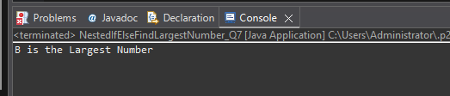
-----------------------------------------------------------------------
8.

Given age and salary: - Done

If age < 25 → Not eligible

If age ≥ 25 and salary < 30000 → Eligible for loan A

If age ≥ 30 and salary ≥ 50000 → Eligible for loan B
➡️ Use deep nested if

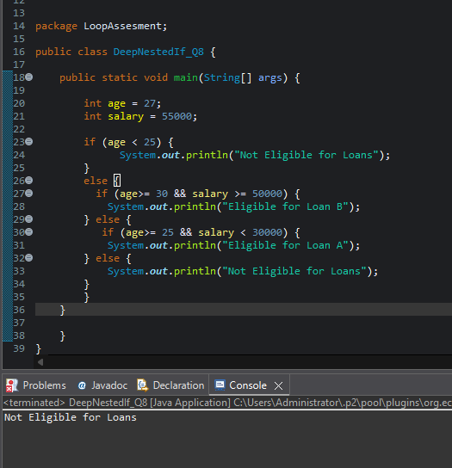
-----------------------------------------------------------------------
9.

Write a program that classifies a character as: - Done

Uppercase vowel

Uppercase consonant

Lowercase vowel

Lowercase consonant

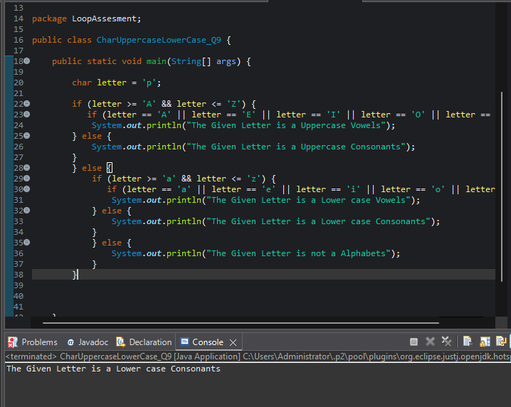
-----------------------------------------------------------------------
10.

Input a number and check: - Done

If it’s a 3-digit number

If yes, check whether the sum of digits is even or odd
➡️ Use nested if only

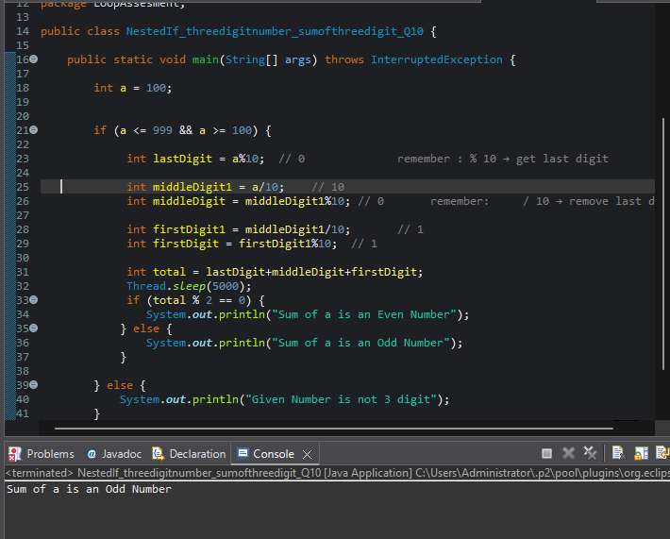
-----------------------------------------------------------------------
-----------------------------------------------------------------------

🔹 WHILE LOOP (Tricky Iterations)
11. - Done

Print numbers from 1 to 100 but:

Skip numbers divisible by both 3 and 5

Stop completely when number reaches 77
➡️ Use while only

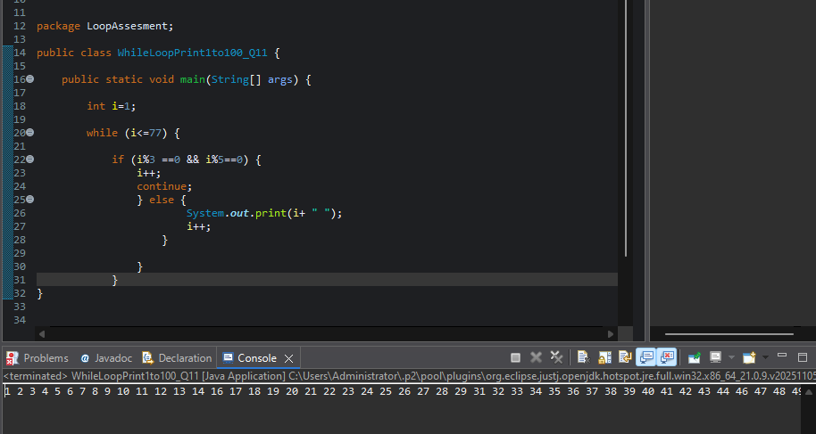

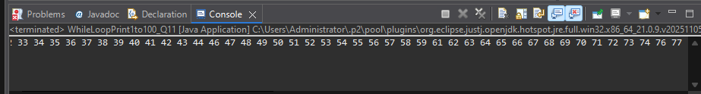
-----------------------------------------------------------------------

12. - Done

Write a program to reverse a number using while, but:

Stop reversing if digit 0 is encountered

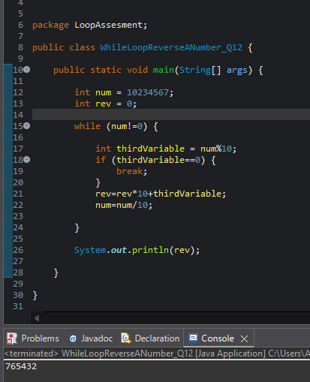
-----------------------------------------------------------------------

13. - Done

Find the count of prime digits in a number using while loop only

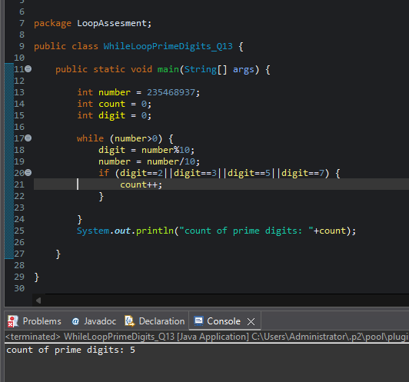
-----------------------------------------------------------------------

14. - Done

Write a program that prints the Fibonacci series up to N terms, but:

Stop printing when a number exceeds 500

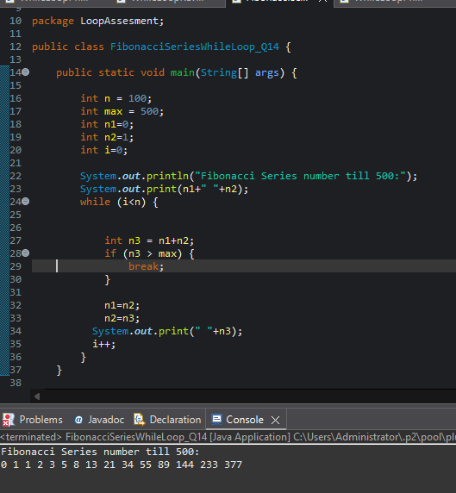
-----------------------------------------------------------------------

15. - Done

Using while, print the following sequence:

1 2 4 7 11 16 22 ...

(up to N terms)

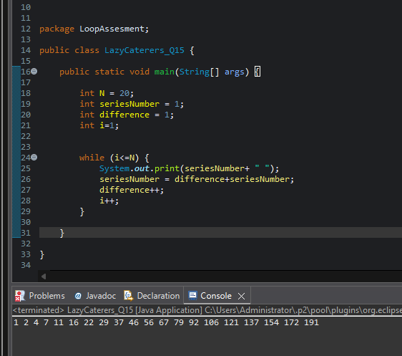
-----------------------------------------------------------------------
-----------------------------------------------------------------------

🔹 DO–WHILE LOOP (Edge Cases) - Done

16.

Write a program that:

Takes user input until a negative number is entered

Prints sum of all even numbers entered
➡️ Use do–while

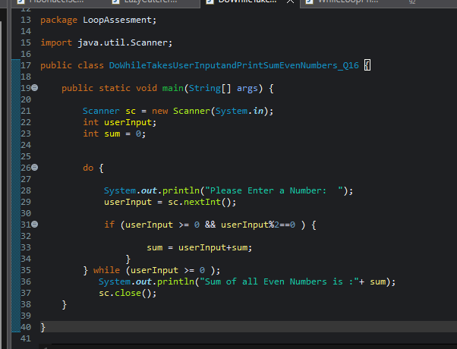

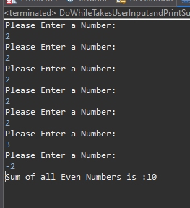
-----------------------------------------------------------------------

17.

Using do–while, print digits of a number from left to right
(No strings, no arrays)

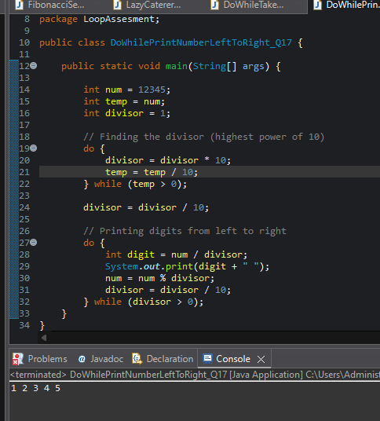
-----------------------------------------------------------------------

18. Done

Write a program that executes at least once, even if condition is false, and prints:

Loop Executed

➡️ Modify condition logically

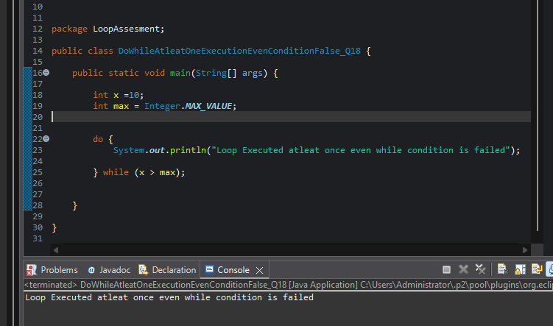
-----------------------------------------------------------------------
19. - Done

Create a menu-driven program using do–while:

Add

Subtract

Multiply

Exit

package LoopAssesment;

import java.util.Scanner;

public class DoWhileMenuDrivenProgram_Q19 {

public static void main(String[] args) {

int num1;
int num2;
int result;
char op;

Scanner sc = new Scanner(System.in);

do {
System.out.println("Enter an operator: +,-,*,&");
op = sc.next().charAt(0);

if (op != '&' && op != '+' && op != '-' && op != '*') {
System.out.println("Entered Operator is not valid");
break;
}
if (op == '&') {
System.out.println("System Exited");
break;
} else {
System.out.println("Enter 1st Number: ");
num1 = sc.nextInt();
System.out.println("Enter 2nd Number: ");
num2 = sc.nextInt();
}
if (op =='+') {
result = num1+num2;
System.out.println("Addition value: "+ result);
}
if (op =='-') {
result = num1-num2;
System.out.println("Subraction value: "+ result);
}
if (op =='*') {
result = num1*num2;
System.out.println("Multiply value: "+ result);
}

} while (op == '+'||op == '-'||op == '*');

sc.close();
}

}
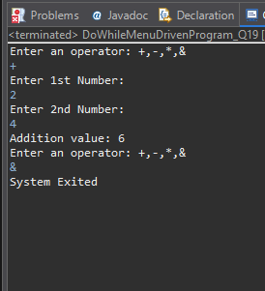
-----------------------------------------------------------------------

20. - Done

Using do–while, find whether a number is palindrome, but:

Exit loop early if mismatch is found

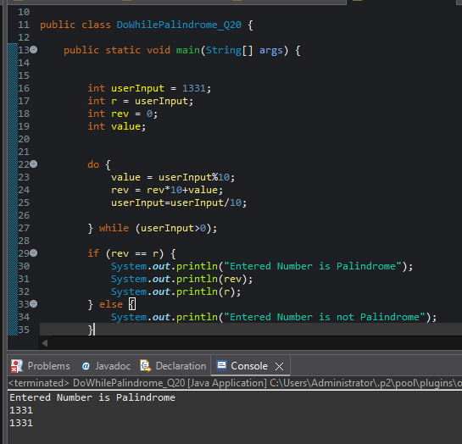
-----------------------------------------------------------------------
-----------------------------------------------------------------------

🔹 FOR LOOP (Advanced Logic)
21. - Done

Print all numbers between 1 and 500 that:

Have exactly 3 divisors

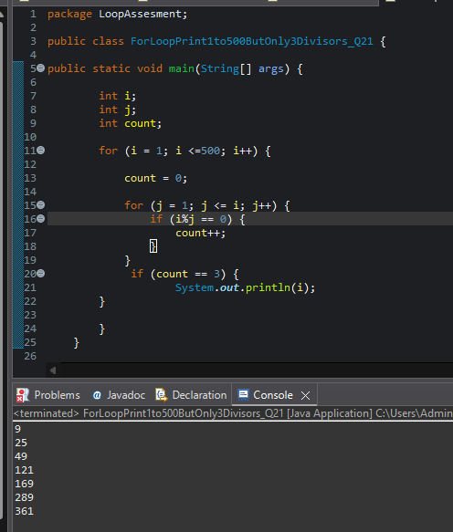
-----------------------------------------------------------------------
22.

Using for, find the largest palindrome number between 100 and 1000

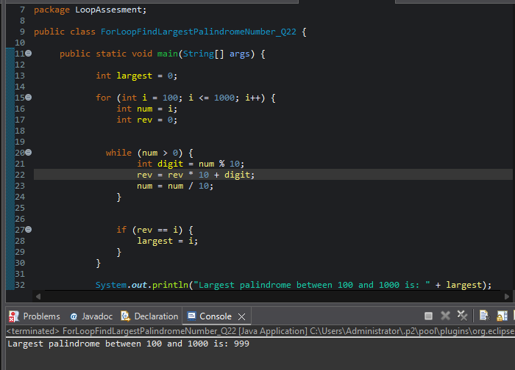
-----------------------------------------------------------------------
23.

Print this pattern using nested for:

1
12
123
1234
12345

But skip printing 3 in all rows

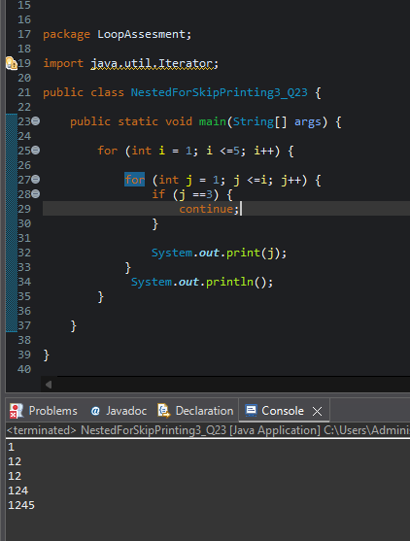
-----------------------------------------------------------------------

24.

Using nested for, print:

5 4 3 2 1
4 3 2 1
3 2 1
2 1
1

But do NOT use subtraction operator (-)

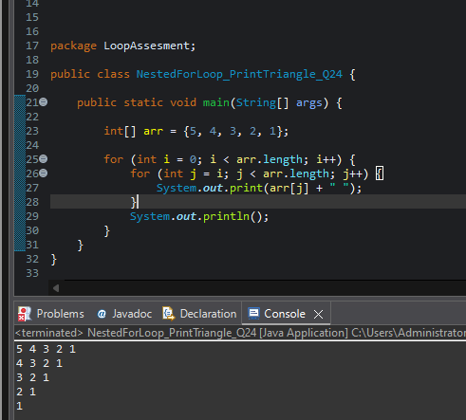
-----------------------------------------------------------------------
25.

Write a program to print all perfect numbers between 1 and 10000 using:

Nested for

if condition only






